01 April 2021

Dear Colleagues

On 18 March the Secretary of State confirmed a £6.6bn funding package for health and social care services, which includes £594 million funding to continue current hospital discharge programmes. The funding provides flexibility to health and care systems to be able to respond to demand for services in the coming months, including being able to continue to deliver designated settings.
The government’s position remains that any patient who has tested positive for the virus within the last 14 days cannot be discharged into a care home and therefore needs to be discharged into a specifically designated setting so they can receive appropriate care in a COVID secure environment. The discharge funding announced last week should be used to ensure each local authority has access to designated settings provision. The Designated Settings Indemnity Support (DSIS) will also be extended until 30th June 2021, in order to maintain the current level of support for these vital settings.
I am aware decisions are being made at a local level about how to continue provision of designated settings over the coming months when demand is expected to be low. Where current arrangements, in partnership with the NHS, are working well to meet local need for designated settings within CQC-assured settings, I encourage you to continue to manage this provision in the interim period before the long-term policy is finalised. If you are experiencing challenges to delivering designated settings, please make contact with your DHSC regional lead and we will support you with thinking through the options for service provision.
I hope the continuation of funding for discharge programmes will come as welcome news. Thank you all for your ongoing efforts throughout the pandemic response.

Yours sincerely

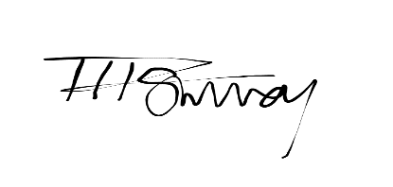
Tom Surrey
Director, Adult Social Care
Department of Health and Social Care

