Winter Vaccines Campaign
Adult Social Care Communications Toolkit
Updated – October 2021

- How this document should be used
- Narrative
- Shareable social media content and blogs
- Marketing materials
- FAQ
- Useful links

How this document should be used
This communications toolkit can be used to provide information and advice to social care workers in all care settings in England about the flu vaccine and COVID-19 booster.

Links to available resources are included below and these can be used to share through your own channels and networks, or as a basis for creating your own communications materials.

Narrative

- Social care workers are eligible for a free flu vaccine and a COVID-19 booster vaccine to help protect themselves and the people they care for this winter.
- These vaccines save lives. Speak to your employer about booking your flu vaccine as soon as possible. The NHS will contact you directly to let you know when it is your turn to get a COVID-19 booster vaccine.
- This autumn/winter, the NHS is preparing for a bad flu season alongside rising cases of COVID-19, which is why taking up any offer of flu or COVID-19 booster vaccines is so important. They are the best protection for you and for those you care for from these deadly viruses – get yours booked.
- It’s easy to pass on the COVID-19 or flu virus without knowing. Even if you’re healthy, you can still get COVID-19 or flu and spread it to the people you care for.
- People at high risk from COVID-19 are also likely to be at risk from flu. Fortunately, we now have safe and effective vaccines to give us the best possible protection from both.
- Last year we saw that those infected with both flu and COVID-19 were more at risk of severe illness or even death.
- Help protect yourself and the people you care for by booking your free essential winter vaccines as soon as possible.

Shareable Content
The following content can be shared across your own channels and networks to encourage care home workers and social care workers to take up the winter vaccines. This section will be updated regularly as new content becomes available.
Expert videos | - Dr Amir Khan, Dr Dawn Harper and Dr Karan Ranj explain why it is more important than ever for people to get their winter vaccines (flu and COVID-19 booster)[LINK]  - Video from Dr Nikki Kanani from NHS England about the importance of vaccination [LINK]  - Video from Dr Fatima Hussain from the Royal college of Obstetricians & Gynaecologists on fertility and the Covid-19 Vaccine [LINK]  - Video from Dr Edward Morris from NHS England speaking on the Covid-19 vaccine and pregnancy.[LINK] | 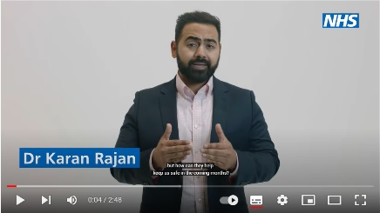  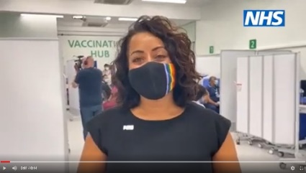  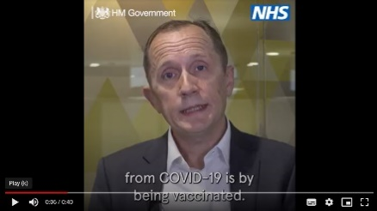  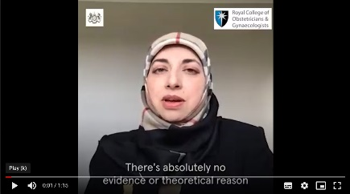
Case study blogs | - Evergreen care home on why flu and COVID booster vaccines are so important to them this winter [LINK]  - Sofija Igonkina, who works at Evergreen care home in Hastings, shares her reason for getting her COVID-19 vaccine. Read her blog here:[LINK] | 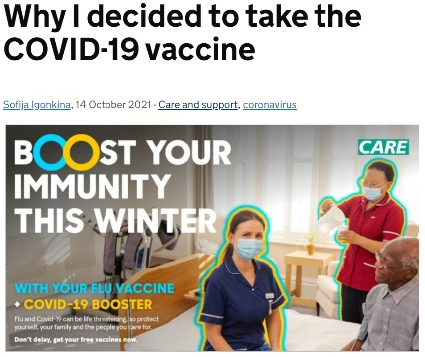
Case study videos | - Dr Rajesh Pandey and other health and care professionals visit Evergreen care home in Hastings to vaccinate residents and explain the importance of getting both vaccines this winter. [LINK] | 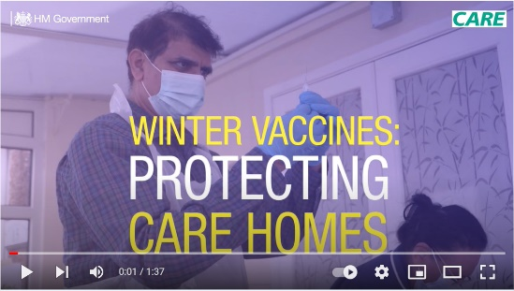
Expert blogs | - Dr Éamonn O'Moore from Public Health England on why vaccination is vital for social care workers. [LINK] | 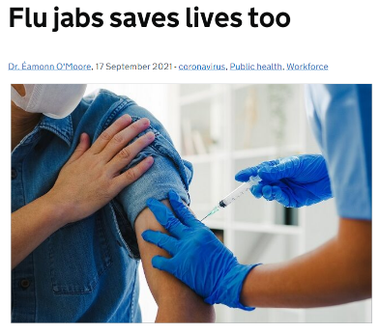
Winter Vaccines Content | - Additional winter vaccines social media content on flu and COVID-19 boosters [LINK]  - You can access a wide range of content addressing key concerns about the COVID-19 vaccines here: [LINK]  - A wide range of content with key facts on the Covid booster jab can be found here: [Link]  - A graphic announcing social care workers are now able to book their COVID-19 booster jab can be found here:[LINK] | 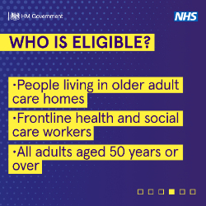  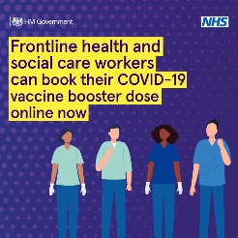

Marketing Materials

The following marketing materials are available to download from Public Health England’s Campaign Resource Centre, to encourage care home workers and social care workers to take up their winter vaccines. You can download and order printed materials here: [LINK]

Q&A Leaflet for staff
[LINK]
DL Leaflet for staff
[LINK]
Posters x 4  Empty belly posters x 4 | 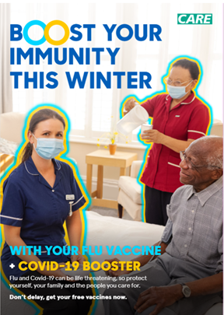  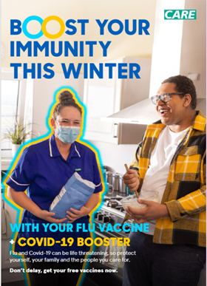  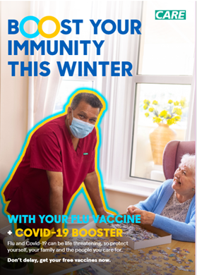
Social Media Square x 4 | 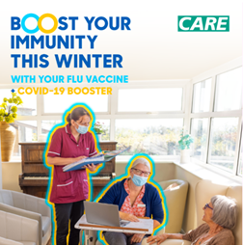  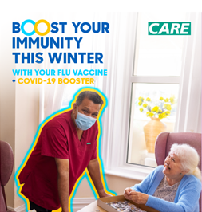  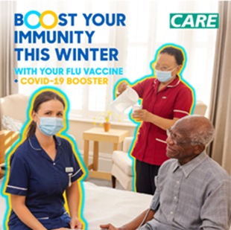  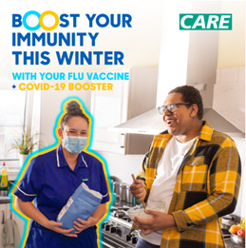
Social Media Landscape x4 | 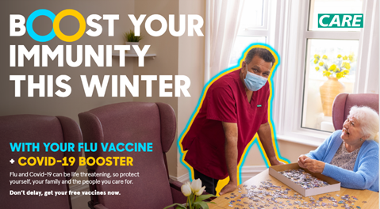  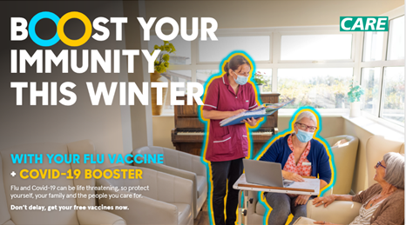  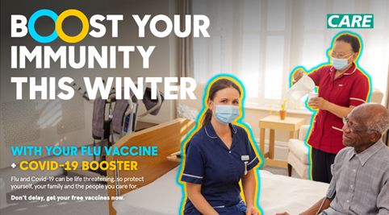  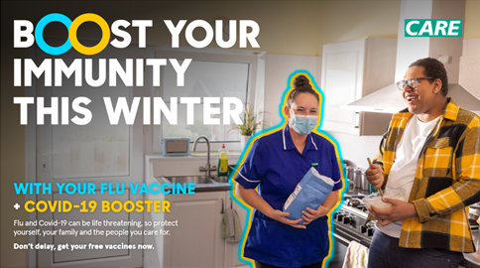
Email Signature x 4
Sticker

FAQ
A detailed FAQ on the COVID-19 vaccines can be found below, with information on how social care workers will access their vaccinations as well the vaccines themselves [LINK]

Useful Links

- Flu vaccination guidance for social care workers [LINK]
- Find a pharmacy that offers the flu vaccine [LINK]
- NHS Covid-19 Vaccination National Booking Service [LINK]

