Exploration of Mindfulness

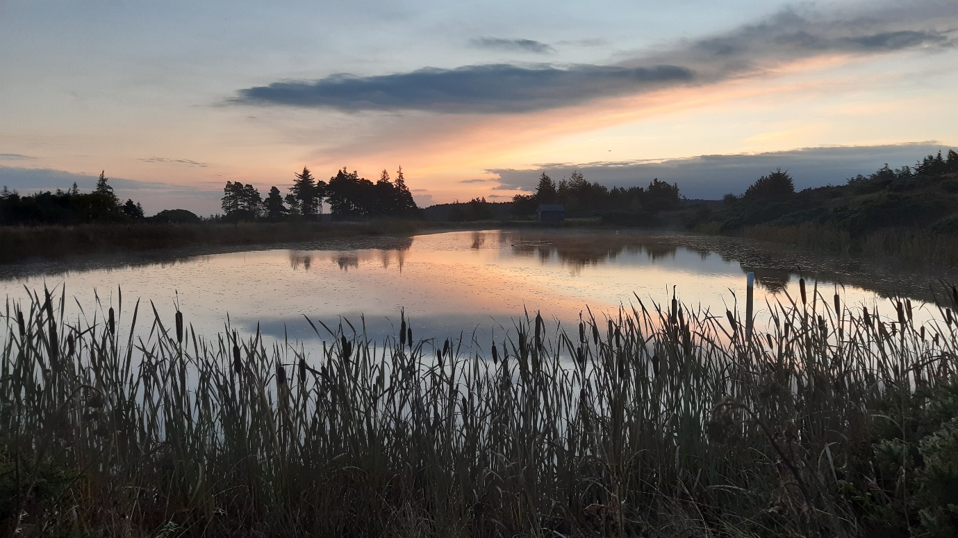
It can be easy to fill your mind with all the tasks and jobs you need to complete, and with the inevitable distractions of home responsibilities and the current pandemic, plus the impact of a lack of social interaction can have, and you will start to see why your energy levels require a boost.
Did you know that building some internal recovery time into your day can be a powerful way to recharge your batteries?
This is where Mindfulness as a tool can help. It is extremely practical and easy to do. It is a natural human behaviour, does not belong to any particular tradition or religion - and is accessible to everyone.
Some of the most successful business owners and entrepreneurs practice Mindfulness.
What is Mindfulness?
“Mindfulness is the awareness that arises from paying attention, on purpose, in the present moment and non-judgementally” Jon Kabat-Zinn.
It means being fully aware of our thoughts and feelings and thinking about where we are and what we are doing. It means not getting overwhelmed by situations or over-reacting to what is going on around us.
It means understanding ourselves better and making ourselves open to new experiences. Enjoying the world around us and seeing the positives.
“Mindfulness also allows us to become more aware of the stream of thoughts and feelings that we experience….and to see how we can become entangled in that stream in ways that are not helpful.” Professor Williams, Oxford Mindfulness Centre.

How will Mindfulness help you?
What Mindfulness is not is a fad. It is based on neuroscience and the evidence to back up the claim that it works.
It helps us cope in our busy lives if we are willing to let it. It can be a useful way of relaxing, reducing stress, giving you some perspective; also, clearing your mind and enhancing your creative side.
Want to see for yourself?
Join me for a 30 minute exploration session, and I will give a brief further explanation of Mindfulness with some useful practical tips. We will go deeper into the benefits, and how you can utilise the natural environment to maximum effect – and we will finish the session with a 12-minute exercise.
Testimonials
“Really enjoyed Karl Beckett’s introduction to Mindfulness session this morning. It was quite amazing how he managed to make everyone feel so at ease in a 30 minute Zoom session. I hope to put some of his useful tips into practice to increase my focus and resilience.”
Gemma Holmes Senior Associate Solicitor of EMG Solicitors Limited

“Fabulous mindfulness session today, took me to a calm place and emphasising why getting in touch with nature is so important in these stressful times.. thanks again and looking forward to the next one…recommended to all..”
Ian McClelland, Videographer and Photographer

“Thank you for the introduction to mindfulness session on Friday, really enjoyed it. The timing and duration were great as was the content and delivery…thank you. “
Paul Drake Operations Director Sapere, making software work for your business.

Karl

