Social Care Leaders Scheme

Introduction

The document proposes the creation of a national scheme to attract, train, develop and retain graduates into the social care sector, primarily to help address the shortage of talent at Registered Manager level, a post which has been identified as crucial for attracting and retaining quality staff, and thereby improving the quality of care and support provided.

The proposals in this paper have been submitted to the Department of Health and Social Care and are currently under consideration.

Context
The challenge of providing a social care system that is fit for purpose is significant. Addressing the recruitment and retention crisis requires bold thinking. Further funding to support front-line care workers must be supported by investment in leadership. Outstanding local leaders are proven to be key to building a happy and motivated workforce delivering excellent care and staying in post for longer.

We need to recognise the vital role registered managers have in ensuring the delivery of high-quality care and developing a skilled workforce in their organisation. We will explore options to develop new pathways into the registered manager role.
- People at the Heart of Care: Adult Social Care Reform White Paper, December 2021

Social care needs to challenge itself to work differently and learn from other industries. We need a talent pathway that will attract those who would not naturally have chosen social care as their sector of choice, to its many opportunities. This new genre of leader will inspire and motivate teams by creating learning cultures that embrace quality. A disruptive scheme is needed to deliver this.
- Nadra Ahmed OBE, The National Care Association

As with other public services, the social care sector urgently needs to attract high-calibre candidates who can lead long-term change. This requires a new, disruptive, initiative to make the social care sector a career of choice for the brightest and best.

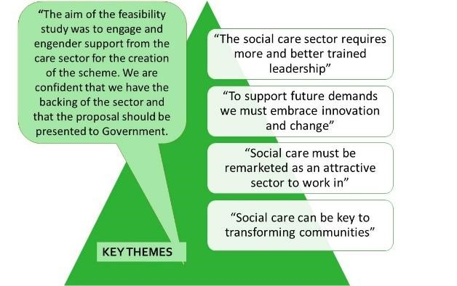
Through our extensive stakeholder engagement in the feasibility study for this proposition, we spoke with care providers and member organisations to understand the realities of leadership in today’s care system. We identified that within the current care system, the Registered Manager role is critical to achieving successful change. We envisage the Social Care Leaders Scheme supporting a generation of change leaders. Where successful Regional Managers are in place, they are the first line of leadership and they can significantly improve the fulfilment of all front-line care workers. We have also found that where a great Registered Manager is in place, job retention and recruitment is better.

The NHS approach to attracting and developing leaders, as well as schemes elsewhere in the public sector – both in the UK and abroad – provide powerful examples that can be tailored to deliver talent recruitment and leadership development that can transform the care sector.

The Social Care Leaders Scheme’s purpose is to attract and develop over 1,000 talented and inspirational new local leaders from outside the sector over the three two-year cohorts. Importantly, the new scheme will be rooted in the powerful charitable purpose of improving the quality of social care in the UK. Providing this powerful social value proposition has been a key element of the schemes on which this approach builds.

What is the problem?
Adult social care is under extreme pressure. Staffing crises are well-documented. Increased funding and recruitment campaigns will not resolve the problem, particularly if the sector is seen as an employer of last resort for many and if turnover remains at 30% or more. A root cause of the challenge is ill-equipped leadership. There are committed, talented leaders, but they are too few and far between.

Much of this is systemic: as the sector is not seen as a desirable career choice, there is a lack of high-calibre candidates for leadership roles. Most new care home managers are, therefore, promoted from care roles; they report low levels of support and training, as well as poor job satisfaction. As a result, 12% of Registered Manager posts are unfilled, and the turnover rate for Registered Managers – 25% in 2019/20 – is high and rising. Only 25% of new Registered Managers are from outside the sector.

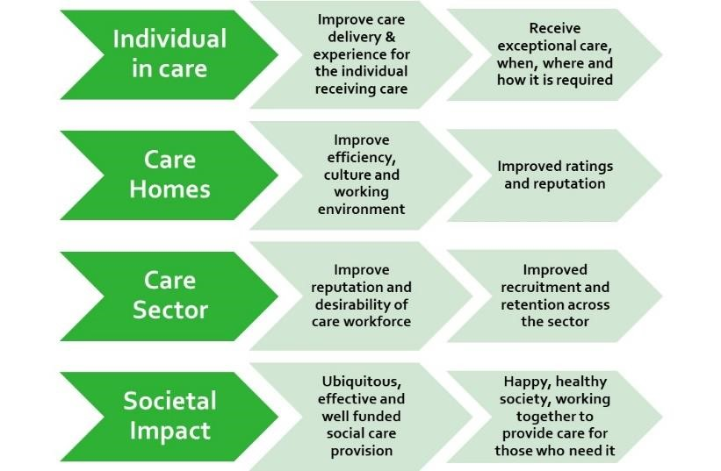
Our proposal
We propose to transform the quality of local team leadership in the social care sector that will:
- help the sector deliver exceptional care to some of the most vulnerable in society;
- improve the quality, efficiency and effectiveness of care homes, improving their reputations and ratings;
- make the care sector a more desirable place to work, improving recruitment and retention; and,
- help ensure wider society has the care system it deserves.
We will do this by creating a recognised accelerated career pathway, and qualifications that are universally accepted, to increase the attractiveness of key local leadership roles in social care and attract some of the best and brightest graduates. Unlike the NHS and other areas of the private and public sectors, no such scheme currently exists across the care sector.

The key elements of the proposal are:
- Participants will undergo a rigorous selection process
- They will be provided with an initial, intense residential training programme
- All those on the programme will be recruited to entry-level front-line care roles
- Further training, mentorship and support will be provided over the following two years
- Participants will provide care in a range of settings to broaden their experience
- They will be expected to be supported through an accelerated progression to a Deputy Manager
- They will also be expected to achieve a Level 5 qualification in Social Care and a Master’s qualification will be available.
- At the end of their two years, and subject to CQC approval, the expectation will be that participants will be ready to secure a position as Registered Manager.

The programme will be expanded to provide routes into other management roles in the sector and there is an expectation that participants will further develop their careers.

Why a graduate recruitment scheme?
Why do employers hire and train graduates? The broad answer is that they provide a source of home-grown talent that complements their resourcing strategies. How the return on investment is realised varies by sector but graduate programmes aren’t just for the Civil Service, Goldman Sachs and Clifford Chance. Enterprise Rent-a-Car hire over 1,000 graduates per year and it is the only way to join their business. Aldi hire all their area managers through their graduate programme. The NHS runs a highly successful graduate management route outside of the core medical programmes.

There is a debate about graduate vs non-graduate programmes but to ignore this sector is to ignore the 400,000+ students who graduate from a first degree every year. And once salary expectations are met, students rate training as the most important factor in choosing an employer, with working in a sector that provides social value factoring very highly in their thinking as well. Programmes such as Teach First, Police Now, Unlocked and Frontline demonstrate how a career path can be created for graduates into sectors that face a talent shortage, and which had previously struggled to attract graduates.

Why us?
The scheme has been developed under the auspices of James Darley and Dame Julia Cleverdon DCVO CBE, who, as Executive Head of Recruitment and Chair respectively, recruited over 10,000 graduates for Teach First over 15 years, built an award-winning employment brand and supported other highly successful graduate programmes across areas of the public sector previously seen as unattractive for graduates. The scheme will build on the foundations of these successful programmes, as well as on learning from elsewhere in the private and public sectors, particularly the NHS.

The proposed scheme has been developed with and commands the support of the social care sector, with its steering group members including Care England, the National Care Association, the National Care Forum, the Institute for Health and Social Care Management, and Skills for Care. The scheme development to date follows a comprehensive and detailed feasibility study undertaken in 2021 by the University of Edinburgh and Transform Society, commissioned by the CareTech Charitable Foundation and which engaged extensively with a wide range of SME, larger care providers, charitable providers and wider stakeholders.

The scheme proposed would be a charitable venture delivering a clear public benefit, and, if it receives government support, would be run entirely on a not-for-profit basis. Indeed, the development of the scheme to date has been funded by the CareTech Foundation, the charitable arm of Caretech PLC, which has also agreed to incubate the new organisation, with additional support from the Hallmark Care Homes Foundation as well as Anchor Hanover. Two of the UK’s largest care-providing charities, Mencap and Leonard Cheshire, have been instrumental in shaping the scheme, as have the Care Quality Commission, Unison, and, importantly, Skills for Care, the charity which partners the Department for Health and Social Care to help train and develop the social care workforce.

The scheme will also incorporate learning from abroad, including the Netherlands, Denmark and Norway, that have shifted primary and secondary social care to a successful patient-centric integrated system.

Social carers are critically important for ensuring that people can live as well as possible in later life. They do an amazing job despite working in an undervalued and underpaid sector but recruiting and retaining the best staff means we need to offer more opportunities for high-quality training and career progression. The proposed social care leadership scheme offers a way to achieve the much-needed shift towards valuing care staff.
Bruce Guthrie - Professor of General Practice and Director of The Advanced Care Research Centre, University of Edinburgh

Next steps
The proposals are currently under consideration by officials at the Department of Health and Social Care. Further details of the scheme have been provided, and are appended to this paper:
- Appendix A: a paper providing more detail of the proposals, including costings.
- Appendix B: a full – draft – Programme Manual.

Further meetings with officials will be held later in January 2022.

Steering Group membership
This submission is provided on behalf of the Social Care Leaders Scheme Steering Group, whose members are:
- Professor David Grayson CBE (Chair) – Professor Emeritus of Corporate Responsibility at Cranfield School of Management and Chair of Leonard Cheshire.
- Nadra Ahmed DL OBE - Executive Chairman - National Care Association
- Dame Julia Cleverdon DCVO CBE – former Chair of Teach First
- Jonathan Freeman MBE – CEO, CareTech Foundation
- Professor Martin Green OBE – CEO, Care England
- Vic Rayner OBE – CEO, National Care Forum
- Oonagh Smyth – CEO, Skills for Care
- Jon Wilks – CEO, Institute of Health and Social Care management
- James Darley – CEO, Transform Society

Contact Details
Jonathan Freeman
Chief Executive Officer, CareTech Foundation
jonathan.freeman@caretechfoundation.org.uk
07931534766

