Stephen Chandler, ADASS President 2021 – 2022
Director of Adult and Housing Services,
Oxfordshire County Council and Cherwell District Council

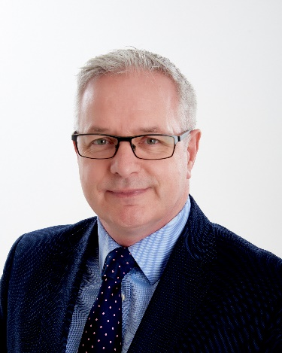

Stephen joined Oxfordshire County Council in September 2019 as the Director of Adult Services (DASS). Since then he has also taken responsibilities for housing services within Cherwell District Council. He has been the ADASS President since April 2021.

Stephens career began in the NHS initially as a nurse and latterly in several NHS director roles including operating at Trust Board level. Following a period as a joint commissioner his most recent positions have been within local government in several assistant director and director of adult services positions.

Stephen has developed innovative models of adult social care with a focus on earlier invention, partnership and market inclusiveness. He has a passion for co-production, improving quality and led the introduction of #doityourway a model of ‘Promoting Independence’ during his time as Director in Somerset. He has since then further developed this approach in Oxfordshire often referred to as the ‘Oxfordshire Way’ S

As a system leader Stephen is Oxfordshire County Councils lead on the emerging Buckinghamshire, Oxfordshire and Berkshire West (BOB) ICS and has recently taken on joint responsibility for urgent care.

During 2018-19 Stephen worked closely with BBCs Panorama team as they spent time within Somerset filming for the 2 part ‘Crisis in Care’ programmes. This saw from conception to broadcast the work associated with creating a powerful narrative about the role and impact Adult Social Care has and how to work with the media to maximise impact. A once in a lifetime experience.

As ADASS President Stephen has sought to be ‘Critical Friend’ within the sector supportive and challenging as appropriate. With the beginning of the reform of Adult Social Care this is an exciting time to be involved supporting the sector, people being supported, their families, those who work within it, partners and organisations. Stephen sees his approach to innovation, a focus on value and leadership and critical to delivering the full potential of reform.

